
INDIAN SCHOOL AL WADI AL KABIR
ASSESSMENT – 1
ECONOMICS SET: 2

Class: XII Max. Marks:80
Date: 17/09/2026 Time: 3 hours

GENERAL INSTRUCTION:
- This question paper contains two sections:
Section A – Macroeconomics
Section B – Indian Economic Development
- This paper contains 20 Multiple Choice Type Questions of 1 mark each.
- This paper contains 4 Short Answer Type Questions of 3 marks each to be answered in 60 to 80 words.
- This paper contains 6 Short Answer Type Questions of 4 marks each to be answered in 80 to 100 words.
- This paper contains 4 Long Answer Type Questions of 6 marks each to be answered in 100 to 150 words.

 | MACROECONOMICS
Q. NO | QUESTIONS | MARKS
 | Study the following figure carefully and choose the correct pair from the  alternatives given below:  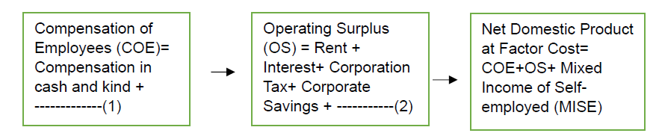  a) Employer’s contribution to social security, Depreciation  b) Employer’s contribution to social security, Dividend  c) Change in Stock, Intermediate Consumption  d) Sales, Net Indirect Tax | 1
 | As per the data presented in the Union Budget 2023-24, the total receipts of the government other than borrowings and the total expenditure are estimated at ₹ 27.2 lakh crore and ₹ 45 lakh crore respectively. The value of the ________ deficit would be ₹ 17.8 lakh crore.  a) revenue  b) fiscal  c) budgetary  d) primary | 1
 | From the given distribution, identify the capital receipt of the government.  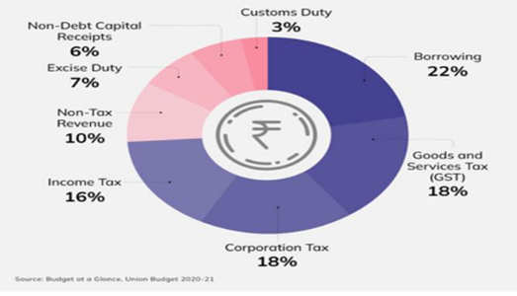  a) 28%  b) 6%  c) 72%  d) 25% | 1
 | Statement 1: Aggregate demand curve is represented by a 45degree line from the origin.  Statement 2: In a two - sector economy, aggregate demand has only two  components- consumption expenditure and investment expenditure.  In light of the given statements, choose the correct alternative from the following:  (a) Statement 1 is true and Statement 2 is false.  (b) Statement 1 is false and Statement 2 is true.  (c) Both Statements1and 2 are true.  (d) Both Statements1and 2 are false. | 1
 | From the statements given in Column I and Column II, choose the correct pair.  Alternatives:  a) A-(i)  b) B-(ii)  c) C-(iii)  d) D- (iv) | 1
  Column I | Column II
  A. Vegetables grown in the personal garden | i) Non-marketing activity
  B. A car used as a taxi | ii) Consumer good
  C. An air-conditioner used by household | iii) Capital good
  D. Scholarship given to students by Government | iv) Factor income
 | At a given point in time, money multiplier is equal to 10. What will be the value of legal reserve ratio?  a) 15%  b) 10%  c) 25%  d) 20% | 1
 | Which of the following can be used to correct the excess money supply under Monetary policy?  a) Cut in the cost of credit  b) Increase in taxation  c) Cut in government expenditure  d) None of these | 1
 | Which of the following is a flow?  a) Deposits in a bank  b) Capital  c) Depreciation  d) Wealth | 1
 | Read the following statements carefully  Statement 1: Consumption and Savings are the components of National output of an economy.  Statement 2: Higher level of Income often leads to lower savings.  In the light of the given statements, choose the correct alternative from the following :  (A) Statement 1 is true and Statement 2 is false.  (B) Statement 1 is false and Statement 2 is true.  (C) Both Statements 1 and 2 are true.  (D) Both Statements 1 and 2 are false. | 1
 | Increase in stock of capital is known as:  a) Capital loss  b) Capital gain  c) Capital formation  d) None of these | 1
 | “Open Market Operations by Reserve Bank of India (RBI) help in regulating money supply in the economy.” Justify the given statement with valid arguments. | 3
 | Elaborate the two components of Aggregate Supply in a two-sector economy. | 3
 | a) Complete the following table.  b) Construct/Express the Consumption function at ₹200 crore level of income based on the table given above. | 4
  Income (in ₹ Cr) | Savings (in ₹ Cr) | Average Propensity to Consume (APC) | Marginal Propensity to Save (MPS)
  0 | (- 30) | - | -
  100 | ------- | 1 | -------
  200 | ------- | 0.85 | -------
  300 | -------- | 0.8 | -------
 | Use the following information of an imaginary country:  i) For which year is real GDP and nominal GDP same & why?  ii) Calculate the percentage change in real GDP for the year 2019-2020 with 2018-2019 as the base year. | 4
  Year | 2017-2018 | 2018-2019 | 2019-2020
  Nominal GDP | 6.5 | 8.4 | 9
  GDP deflator | 100 | 140 | 125
- a.  b. | On the basis of the given data, estimate the value of Domestic Income:  “Basis of classification of final goods into consumption and capital goods depend on the economic nature of its use.” Defend or refute the statement, with the help of a suitable example. | 4
  S No. | Items | Amount  (₹crore)
   | Household Consumption Expenditure | 600
   | Gross fixed capital Formation | 200
   | Change in stock | 40
   | Government Final Consumption Expenditure | 200
   | Net Export | (-) 40
   | Net Indirect Tax | 120
   | Net Factor Income from Abroad | 20
   | Consumption of Fixed Capital | 40
- a.  b. | On the basis of the given information, calculate the values of the following:  (i) Fiscal Deficit  (ii) Primary Deficit  “The Union Budget 2024 – 25 had proposed an allocation of `22,138 crore to the Micro, Small and Medium Enterprise (MSME) Ministry.”  Recognise and explain the objective that the government is trying to achieve  with the proposed expenditure. | 6
  S.no. | Items | Amount (in ₹crore)
  i) | Capital Expenditure | 120
  ii) | Revenue Receipts | 100
  iii) | Revenue Deficit | 110
  iv) | Interest Payments | 25
  v) | Non- Debt Creating Capital Receipts | 40% of Revenue Receipts
- a.  b. | “In an economy, Aggregate Demand (AD) is more than Aggregate Supply (AS).”  Elaborate the possible impacts of the same, on the level of output, income and employment.  Suppose an economy is in equilibrium. From the following data, calculate investment expenditure in the economy:  (a) National Income (Y) = ₹ 10,000 crore  (b) Marginal Propensity to Save (MPS) = 0.2  (c) Autonomous Consumption (c) = ₹100 crore | 6
 | INDIAN ECONOMIC DEVELOPMENT
 | Read the following statements- Assertion (A) and Reason (R). Choose the correct alternative given below:  Assertion (A): World Trade Organization (WTO) is expected to establish the rule- based trading regime, to avoid unilaterally placed arbitrary restrictions by member nations.  Reason (R): It is imperative to enlarge world production and ensure optimum utilization of world resources along with environmental protection.  Alternatives:  (a) Both Assertion (A) and Reason (R) are true and Reason (R) is the correct explanation of Assertion (A).  (b) Both Assertion (A) and Reason (R) are true, but Reason (R) is not the correct explanation of Assertion (A).  (c) Assertion (A) is true, but Reason (R) is false.  (d) Assertion (A) is false, but Reason (R) is true | 1
 | India has attained an enviable position in growing diverse horticultural crops  such as fruits, vegetables, tuber crops, flowers, medicinal and aromatic plants,  spices and plantation crops. This is generally referred to as:  a) White Revolution  b) Green revolution  c) Golden Revolution  d) Blue revolution | 1
 | __________committee was set up for the development and promotion of small- scale industries in India.  a) Karve  b) Tapas Majumdar  c) Mahalanobis  d) Gadgil | 1
 | Read the following statements carefully.  Statement 1: Britain maintained a monopoly control over India's exports and imports.  Statement 2: The export surplus so generated was utilised for developing the Indian economy.  Alternatives:  a) Statement 1 is true and statement 2 is false  b) Statement 1 is false and statement 2 is true  c) Both statements 1 and 2 are true  d) Both statements 1 and 2 are false | 1
 | Benefits of physical capital accrue only to private entities, whereas human  capital provides private as well as _____________benefits.  a) profitable  b) social  c) fiscal  d) monetary | 1
 | A shift from crop farming to other areas of productive activity with a view to raising income known as ________________.  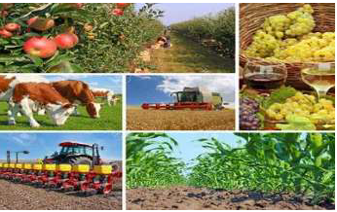  a) None  b) Diversification of productive activity  c) Diversification of crop production  d) Both (b) and (c) | 1
 | Assertion (A): According to the government, the purpose of disinvestment was mainly to increase the resources only.  Reason (R): It was envisaged that private capital and managerial capabilities could be effectively utilised to improve the performance of the PSUs. The government envisage that privatisation could provide strong impetus to the inflow of FDI.  a) Both A and R are true and R is the correct explanation of A.  b) Both A and R are true but R is not the correct explanation of A.  c) A is true but R is false.  d) A is false but R is true. | 1
 | Elementary education takes a major share of total education expenditure and the share of __________ is the least.  a) Secondary Education  b) Tertiary education  c) Primary education  d) University Education | 1
 | Statement I: The opening of the Suez Canal in 1869 reduced the cost of transportation and made access to the Indian market easier.  Statement II: More than 90% of India's foreign trade was restricted to Britain while the rest was allowed with a few other countries like China, Ceylon (Sri Lanka) and Persia (Iran).  a) Statement II is true, but statement I is false.  b) Both the statements are false.  c) Statement I is true, but statement II is false.  d) Both the statements are true. | 1
 | Which of the following statements is true about the import licensing reforms under the new economic policy of 1991?  - The import licensing was abolished except in the case of hazardous items  - The import licensing was abolished except in the case of environmentally sensitive industries  - Both a and b are incorrect  - Both a and b are correct | 1
 | In accordance with the goal of the state controlling the commanding heights of the economy, the Industrial Policy Resolution of 1956 was adopted. How was private sector regulated under the resolution? | 3
 | a) Cooperatives play a vital role in the credit availability in rural India.  b) What is operation flood? | 3
 | “In the post-reform period, the Government of India decided to retain profit-  making Public Sector Undertakings (PSUs) by providing them with a special  status”. Critically evaluate the impact of this decision by the central  government. | 4
 | Does modernization as a planning objective create contradiction in the light of employment generation. | 4
 | Do you think the current level of education expenditure is inadequate? Why? | 4
 | a) As a form of economics activity, outsourcing has intensified in recent times. Most MNCs, and even small companies, are outsourcing their services to India. Defend or refute the above statement.  b) What measures have been taken for globalisation of Indian economy? | 6
 | a) “A sound agricultural marketing system works as the backbone of any agro-system of any nation.” List any three steps taken by the Indian government in this direction.  b) There is an increasing demand for organically grown food throughout the world in recent times. Give three advantages of organically grown crops. | 6

